**Art Supply List**

* **9x12** or **7x10** Mixed ~~Media~~ Sketchbook **(Sketchbooks are required)**
* Graphite Pencils or Regular No. 2 pencils
* Pencil Sharpener with lid
* Color pencils (Suggested brand: Prismacolor)

Suggested stores: **Amazon**, Walmart, Hobby Lobby, Michaels or Target

**DEADLINE TO HAVE SKETCHBOOK IS: FRIDAY, AUGUST 29TH**

**\*SEE EXAMPLES BELOW\***

**SKETCHBOOK SUGGESTIONS:**

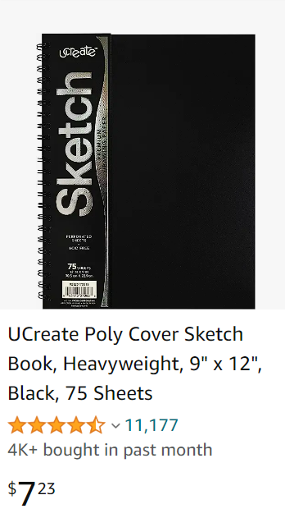 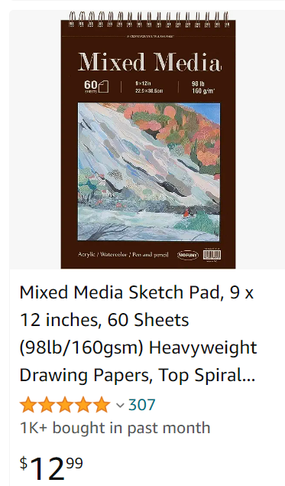 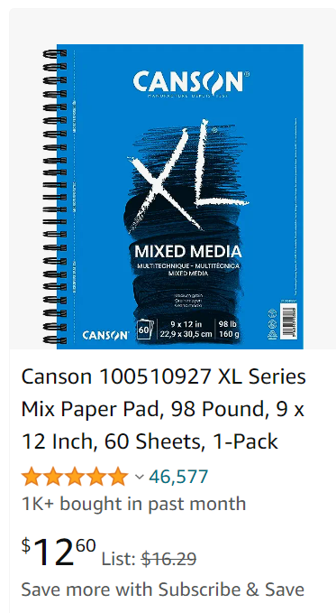

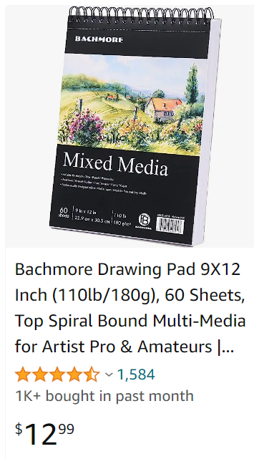 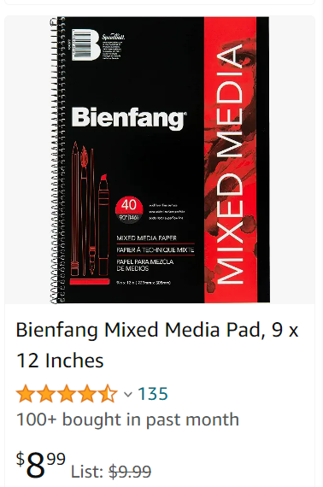

**SKETCHBOOKS MUST BE:**

* **9X12 OR 7X10 IN SIZE**
* **MIXED MEDIA**

**ALL RECOMMENDED SKETCHBOOKS CAN BE FOUND ONLINE AT: WWW.AMAZON.COM**

**GRAPHITE PENCIL SUGGESTIONS:**

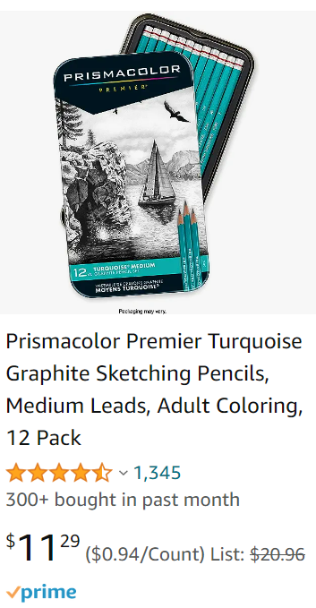

**COLOR PENCIL SUGGESTIONS:**

